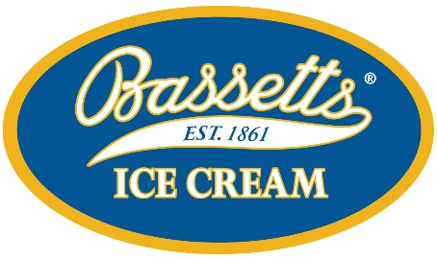
Flavors Ranked in Order of Popularity
- VANILLA
- CHOCOLATE
- COOKIES & CREAM
- STRAWBERRY
- MINT CHOCOLATE CHIP
- SALTED CARAMEL PRETZEL
- FRENCH VANILLA
- PEANUT BUTTER SWIRL
- COFFEE FUDGE TRUFFLE
- MOOSE TRACKS
- RASPBERRY TRUFFLE
- MANGO ICE CREAM
- COOKIE DOUGH
- COFFEE
- BIRTHDAY CAKE
- POMEGRANATE BLUEBERRY CHUNK
- MANGO APRICOT SORBET
- PISTACHIO
- BUTTER PECAN
- MATCHA/GREEN TEA
- DARK CHOCOLATE
- RUM RAISIN
- RASPBERRY SORBET
- DARK CHOCOLATE CHIP
- LEMON SORBET
- CHOCOLATE FUDGE BROWNIE
- BANANA
- PEACH
- ENGLISH TOFFEE CRUNCH
- CHOCOLATE CHIP
- BUTTERSCOTCH VANILLA
- PRALINES & CREAM
- PUMPKIN (SEASONAL)
- TOASTED COCONUT
- CINNAMON
- S'MORES
- CHOC. MARSHMALLOW
- EGG NOG (SEASONAL)

